BY: Henok Bekele

Read me

To run the application follows the following configuration and steps

Installation

* Download and Install **Wamp Server**
* Download and install Perl
* Install JSON::XS Perl module

Configuration

Go to httpd.conf file in C:\wamp64\bin\apache\apache2.4.27 directory

* Add the following parameter

1. AddHandler cgi-script .cgi
2. AddHandler cgi-script .pl

* Add “index.cgi index.pl” in the directory index
* Modify the option index as
  + Options Indexes FollowSymLinks Includes ExecCGI

To run the application

1. put “cgi_happointment” folder inside “cgi-bin” directory of wamp folder
2. Put “happointment” folder inside “www” direcotyr of wamp folder
3. Run wamp
4. Go to <http://localhost/happointment/>

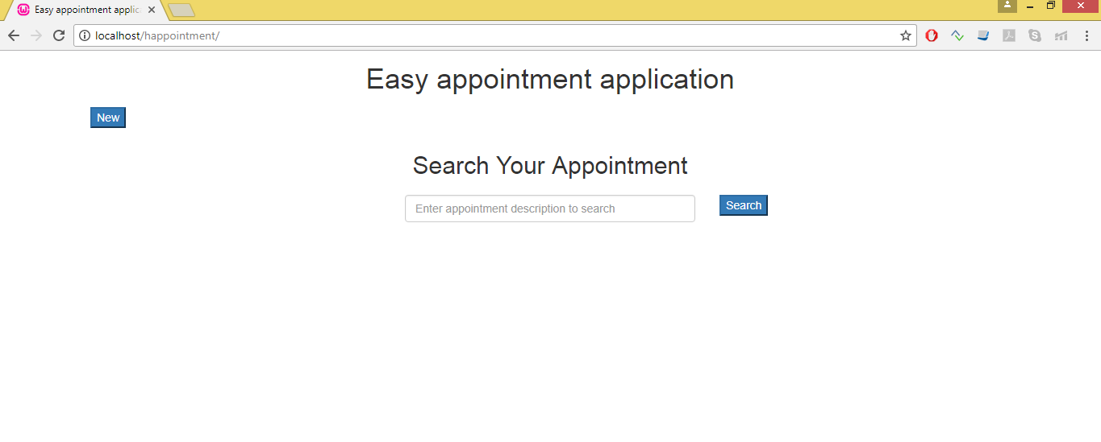

To insert

* Click on **New**
* Enter appropriate date, time and description then click **add**
* If you Enter date that is passed pop up message will be displayed that indicate that the Entered date is not valid as it is less than the current date

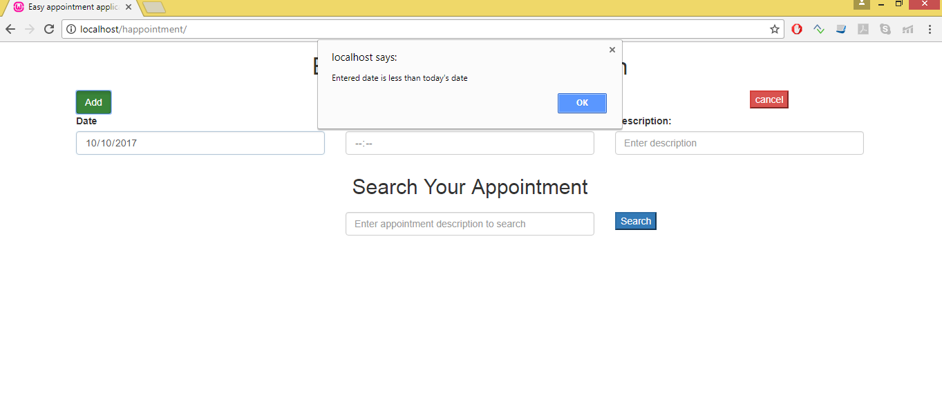

To search

We can search by description

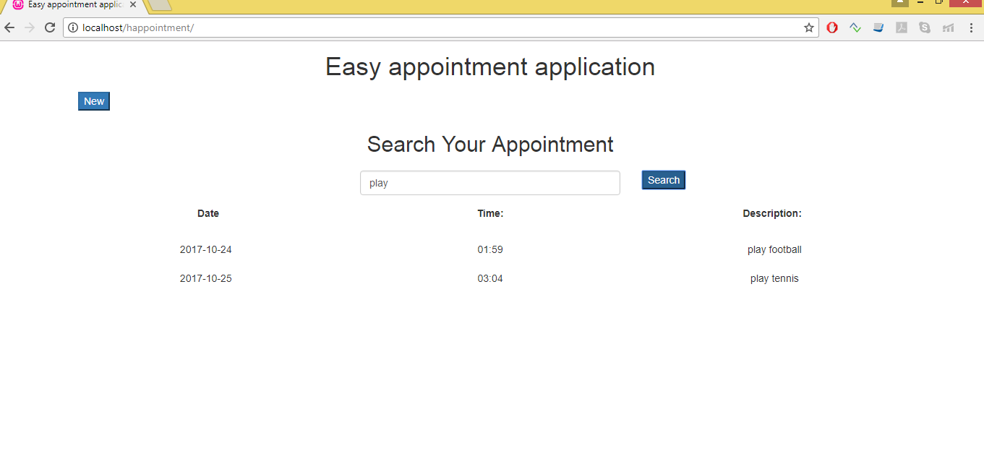

If you click on search without entering it will list all the appointment

